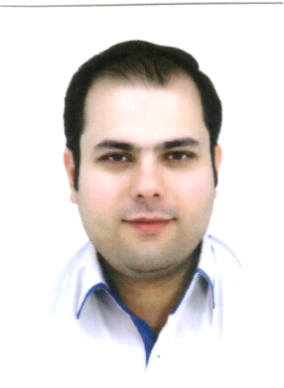

**Resume**

Mahdi Ghanizade Married – (two children)

No. 8 -29 Amoozgar Blvd. Seyyed Razi, Mashhad, Iran

Tel: +98 (051) 361445530

Cell phone: +98 9151220511

E-mail: [ghanizademahdi@gmail.com](mailto:ghanizademahdi@gmail.com)

Objective: Resume

**Education**

2001-2006 Bachelor of Arts in English Literature, Azad University

2006 Tour managing course in Miras organization 6 months

2010 SCBI in Tehran 2 weeks (Teaching methods for Sama overseas school in Tehran)

2013 TICKETING COURSES (Basic, Intermediate and Advance)

2015 Gabriel ticket seller course

2017 Hotel management general course   
2017 Hotel management professional course

**Experience**

2006-2008 In Ehya Gardeshgar Toos travel agency, hotel visor (3 and 4 stars’ hates), Tour manager

2012-2014 Founder and head manager of Sarina Safar Travel agency

2014 Front office manager in Toos hotel (4-star hotel)

2014-2015 Executive manager and duty manager of Simorgh hotel (3-star hotel)

2015- 2016 Manager of Helia hotels group (4-star hotel)

2016-2018 Manager of Simorgh hotel (a 3-star hotel)

2017-2019 Manager of Tara hotel (4-star hotel)

2019-2020 Manager of a hotel apartment which I hired

2020-2023 Manager of Simorgh hotel (top 3-star hotel)

2023-now Duty Manager of Jahan Grand Hotel (a 5-star hotel)

**Skills**  computer, soft wares, internet and network

**Languages**  Fluent English – French and Arabic some deal

**Personal**  Internet, hospitality, ticketing, hotel managing, teach hotel management courses in Danesh Pazhohan institute, travel and football