Nasrullo Tuychizoda

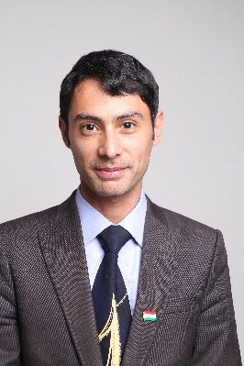

**Personal Information**

**Telephone: Mobile: +992918147207**

**Email: nasrullotj@gmail.com**

**Nationality: Tajik**

**Date of birth: 17.02.1988**

**Gender: Male**

**Education**

**2005 –2010 - Tajik State Fine Art Institute named by Mirzo Tursunzoda**

**Faculty of culturology**

**2010 2014 Post-graduate student in Tajikistan Academy of Sciences Institute of philosophy, political sciences and the law**

**2022- 2024 Master Student of Asian Pacific University of Ritsumeikan, Master of Science in International Cooperation, Japan, Beppu, Oita Prefecture.**

**Work Experience**

**2011 -current time – editor of magazine «Ilm va hayot» under Ministry of culture Republic of Tajikistan**

**2018-2022 - teacher, Academy of Public Administration under the President of Republic of Tajikistan, Department Phycology of Management**

**2010- 2011 specialist Dushanbe city Department of Youth Affairs, Sports, and Tourism**

**2005 – 2010 Journalist in «Charkhi gardun» Newspaper**

**2003 – 2005 Journalist in «Haqiqati Leninobod» regional newspaper**

**Languages** **Tajiki (Persian) - Native Language**

**Uzbek – good written and spoken**

**English - good written and spoken**

**Russian - good spoken and written**

**Turkish** - avarage **written and spoken**

**Japanese- beginer**

**Author 3 books, «Тaronai chasmasor» (Khujand-2000) and «Qissai ohucha» (Khujand-2002) and “Dunyoi sohibdilon” (Dushanbe 2021)**

**Participation in training and practices**

**From12.06.2011 to 26.06.2011 after winning the USA Congress «Open World» program visited California State, USA and had taken the course on “Ecological tourism”.**

**From 20.06.2011 to 25.06.2011 was a Listener of “The school of young Philosopher” in Russian Academy of Science, Moscow, Russian Federation.**

**Listener of scientific-practical conference "Children, Youth and the Ecology: health, education, environment," July 5-9, Barnaul, Altai Republic, Russia.**

**Listener Second International Media School "Conscious Media. Ukraine at the crossroads of cultures ", from 15 to 19 July 2012 in Uzhgorod Zakarpatsk region, Ukraine.**

**From 16.03/2015 to 22.03.2015 listener in Paris Le Monde international Tourism Exbeption , France.**

**International Training Programme on Research Methods in Labour Studies from 08.02.2016 to 26.02.2016 under ITEC/SCAAP Programm Government of India, V.V.Giri National Labour Institute, India, Noida city.**

**Master Student of Asian Pacific University of Ritsumeikan, Master of Science in International Cooperation, Japan, Beppu, Oita Prefecture. From 2022-2024.**